**Tips and Tricks for using Fluke Tech Support GPT**

1. The bot is more likely to provide a precise answer when questions are formulated accurately

eg: " What is #ERR in AMH logic failures?" instead of asking "What is #ERR "

1. If the bot fails to answer the question, consider refining it to be more specific to the domain.

|  |  |
| --- | --- |
| Actual question | Alternate question |
| What is part number for an 8270A manifold? | What is a replacement part number for an 8270A manifold? |

In the source, there is no available data for the part number 8270 A, but it served as a replacement part number for 8270A.

1. If you're asking multiple questions in a single conversation and notice an inappropriate response, consider starting a new conversation and posing the same question again. This is because the bot tailors its responses based on previous interactions, so mixing different questions may lead to irrelevant answers.
2. Clear the conversations periodically, in the Settings option

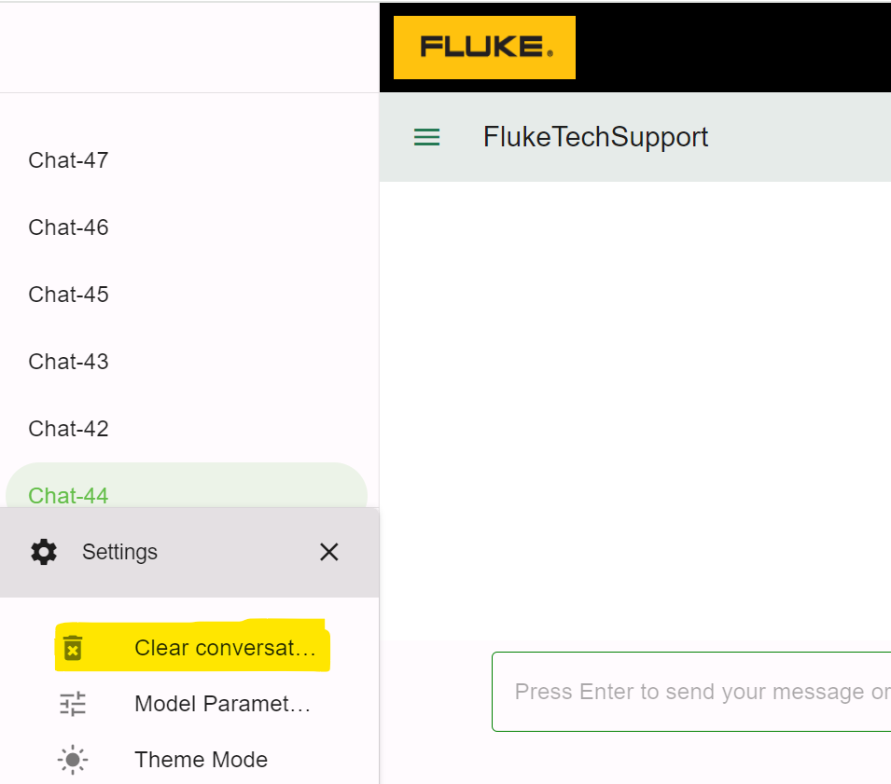

**Note: Clearing conversations will not have any impact on the Bot's response.**

1. In Bot's response, there is a SharePoint location provided where you can access source document suggestions from various SharePoint paths.

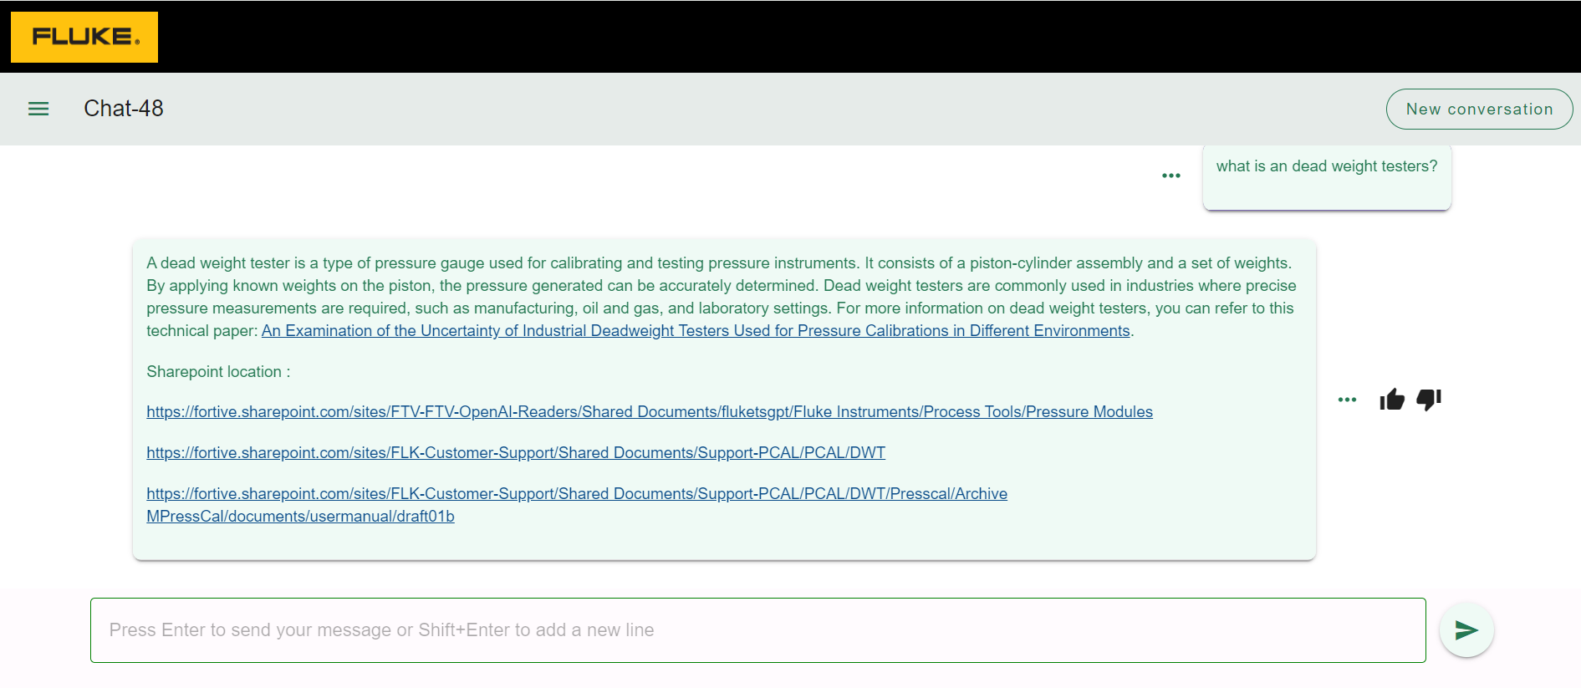

1. If you're unsatisfied with the bot's answer, reiterate the same question in the chat.